**Lyons Document Storage Corporation Case**

By: Jacob Baron, Ben Hoffman, Lucas Lantis, and Reid Zuerlein

***Premium vs. Discount Bonds***

A typical bond is issued at the prevailing market rate for bonds with similar characteristics. Once the bond begins trading in the secondary market, the price of the bond increases and decreases due to movements in the prevailing interest rate for similar bonds. A bond is trading “at a premium” if the present value of the bond is greater than the face value. This happens when the prevailing market interest rate is lower than the coupon rate on the bond. On the other hand, a bond is trading “at a discount” if the present value of the bond is less than the face value. This occurs when the prevailing market interest rate rises after bond issuance to an amount greater than the coupon rate on the bond.

***Outstanding Bond’s Value***

On July 2, 1999 Lyons Document Storage issued $10 million, 8% bonds (paid semi-annually) that will be payable on July 2, 2019. The amount of cash that was received from this bond issue can be calculated by finding the present value of the bonds based on the prevailing market interest rate of 9%. Using these numbers, the company received $9.0799 million from the bond issuance.

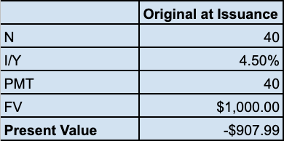

Next, we recomputed the amounts shown in the balance sheet on the financial statements for year end of 2006 and 2007. We found the bond carrying value to be $9.2427 million at the end of 2006 vs the $9.259 million found on the balance sheet. For 2007, we found a carrying value of $9.2752 million vs the $9.292 million on the balance sheet.

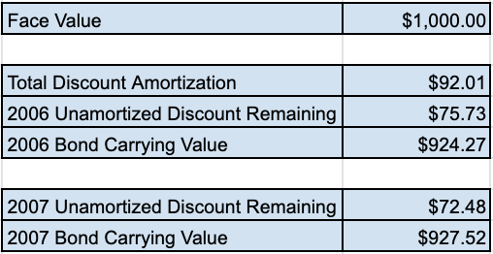

Lastly, we wanted to look at the present value of the outstanding bonds using the current market interest rate of 6% to see what the bonds are worth today. The current value of the outstanding bonds comes out to a total of $11.4877 million meaning that if Lyons wants to take them off the market, they would have to pay at least that much.

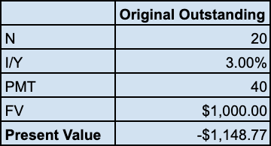

***Recommendation***

If the old bonds are refunded at $1,154.15 (given), the value of the old bonds is therefore $11,541,000. The call premium is $1,541,000. The new bonds have a calculated premium of $1,593,691.66. Since the new bonds have a higher premium, then Rene should refund the old bonds and issue new bonds at a lower market rate. To refund the old bonds, the amount required is $11,541,000. If the current market rate is 6% and the coupon rate is 8%, with semi-annual compounding, that bond should be selling for $1,159.37. To cover the cost, Rene will need to issue 9,955 bonds to cover the cost of refunding the old bonds at $11,541,000. Issuing new bonds will be cheaper in the long run since they are at a lower rate.

***Scenario Analysis***

If 6% bonds could be issued, they would be trading at par because the market interest rate is 6%. The amount to refund the old bonds was calculated as $11,541,000. The 6% bonds would be selling for $1,000 (at par). Therefore, we would recommend Rene issuing 11,541 of these bonds to have enough proceeds to refund the existing bonds.

Grade 25/40

Comments:

- Regular bonds are NOT amortizing loans. All calculations are incorrect.

Roberto Stein , Apr 8 at 3:17pm

- Update: 5 points added because calculation of value of bond at issue is correct.

Roberto Stein , Apr 9 at 8:45am